**One Percent Better Bot**

If someone knows Scaler they know about the term “One Percent Better”. It basically calls upon an individual to keep improving every day in order to be exponentially better than who they were at the start of the year.

In this bot I have made an attempt to mimic just that.

Every day an individual need to enter the term “onepercentbetter” within the server if they want to improve themselves/play this game.

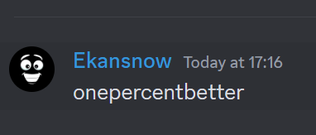

As soon as they enter the term, they would get a direct message from the bot

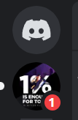

Within the chat they would receive that day’s hidden tech. word.  
like- **i - - o - - a – i o –**

With its meaning.

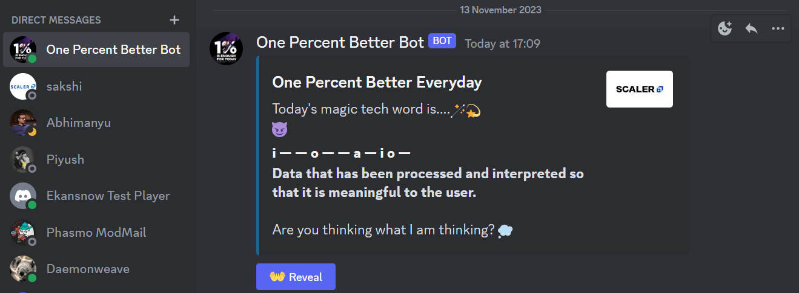

The member has to think of the answer in their mind and then press the button to reveal the answer.

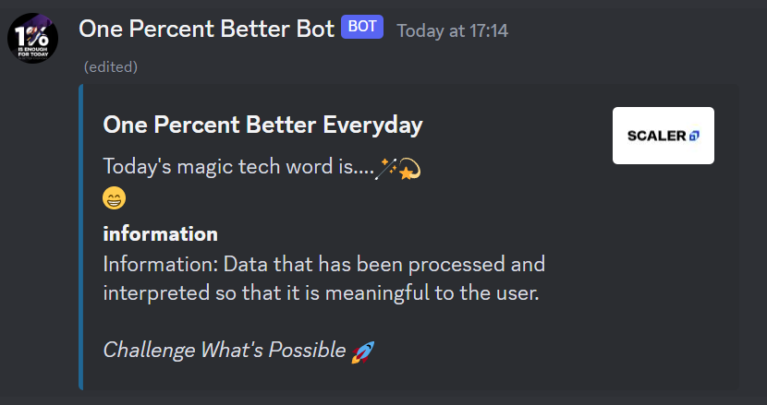

The original message gets updated with the answer. Notice (edited) at the top.

On some days members also get a bonus word and its meaning. Cool huh!

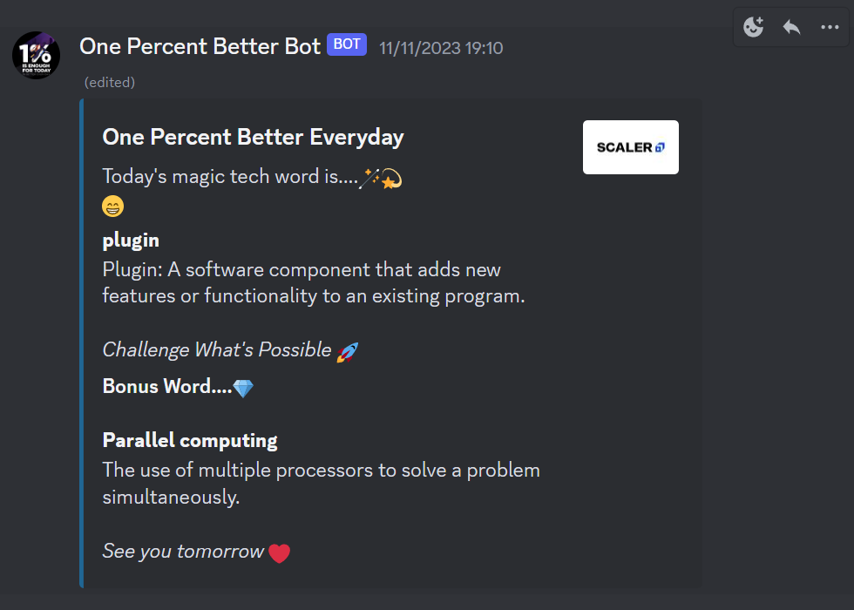

This would help the individuals cultivate **an awesome habit** of working on themselves every single day.  
  
**Highlights: -**

* New words are provided every day. That means playing multiple times within 24 hours won’t improve your tech. vocabulary. You will receive same word for 24 hours even when you play multiple times.
* The excel sheets from where the word is picked contains 365 tech words. So we are sorted for at least an year, from the day, the bot goes live.
* Bonus words are tougher to guess hence are kept in a different sheet from the magic words (easy words) sheet. They pop in randomly.

The fact that you are reading this far tells that you are a dedicated individual who understands business and wants to deliver supreme quality products for your customers. Give me a chance to be Customer Associate at Scaler and I shall do the same as well.

Thank you!